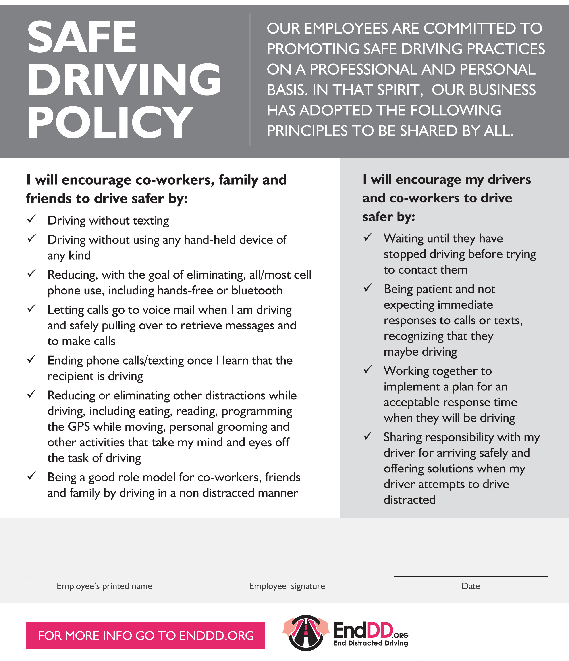

{Your company logo}

Insert your firm name/logo here